**Lab Assignment No. 3 A**

**Name: Usha sree alekhya siddi**

**Class: TE IT A**

**Roll No.: 35071**

**Subject: Web Application Development**

**Title: Create a Node.JS Application which serves a static website.**

**server.js**

const express = require('express');

const path = require('path');

const app = express();

app.use(express.static(__dirname + '/public'));

app.get('/', (req, res) => {

res.sendFile('/index.html');

});

app.get('/about', (req, res) => {

res.sendFile(path.join(__dirname + '/public/about.html'));

});

app.get('/signup', (req, res) => {

res.sendFile(path.join(__dirname + '/public/signup.html'));

});

app.listen(3000, () => {

console.log('Server listening on port 3000.');

});

**index.html**

<html>

<head>

<title>Home</title>

<link rel="stylesheet" href="style.css" />

</head>

<body>

<nav>

<img src="./images/logo.svg" alt="logo" />

<ul>

<li><a href="/">Home</a></li>

<li><a href="/about">About</a></li>

<li><a href="/contact">Contact Us</a></li>

</ul>

</nav>

<div class="home">

<div class="home-container">

<h3>Made for movie + TV lovers.</h3>

<p>

Need something to watch? We're on it. Plex combines free movies & TV

with your favorite streaming services and personal media, so there's

always more to discover.

</p>

<a href="/about">Start Streaming</a>

</div>

</div>

</body>

</html>

**about.html**

<html>

<head>

<title>About</title>

<link rel="stylesheet" href="style.css" />

</head>

<body>

<nav>

<img src="./images/logo.svg" alt="logo" />

<ul>

<li><a href="/">Home</a></li>

<li><a href="/about">About</a></li>

<li><a href="/signup">Sign up</a></li>

</ul>

</nav>

<div class="about">

<h3>About Us</h3>

<div class="about-container">

<div class="about-card">

<img src="./images/alwaysfree.jpg" alt="always free" />

<h4>Always free</h4>

<p>

Finally, a free movie website that's actually free. Watch any time,

no subscription required.

</p>

</div>

<div class="about-card">

<img src="./images/watch.jpg" alt="watch" />

<h4>Tons to Watch</h4>

<p>

Finally, a free movie website that's actually free. Watch any time,

no subscription required.

</p>

</div>

<div class="about-card">

<img src="./images/device.jpg" alt="device" />

<h4>Device-Friendly</h4>

<p>

Finally, a free movie website that's actually free. Watch any time,

no subscription required.

</p>

</div>

<div class="about-card">

<img src="./images/work.jpg" alt="work" />

<h4>Works Worldwide</h4>

<p>

Finally, a free movie website that's actually free. Watch any time,

no subscription required.

</p>

</div>

</div>

</div>

</body>

</html>

**signup.html**

<html>

<head>

<title>Sign Up</title>

<link rel="stylesheet" href="style.css" />

</head>

<body>

<div class="signup">

<h3>Create your free account</h3>

<button>

<img src="./images/google.svg" alt="google" />

Continue with Google

</button>

<button class="facebook">

<img src="./images/facebook.svg" alt="google" />

Continue with Facebook

</button>

<form class="signup-container">

<input type="email" placeholder="Email" />

<input type="password" placeholder="Password" />

<button class="submit">Create an Account</button>

</form>

<a href="/">Back to home</a>

</div>

</body>

</html>

**style.css**

@import url('https://fonts.googleapis.com/css2?family=Poppins:wght@100;200;300;400;500;600;700;800;900&display=swap');

* {

margin: 0;

padding: 0;

box-sizing: border-box;

font-family: 'Poppins', sans-serif;

}

/* navbar */

nav {

display: flex;

align-items: center;

justify-content: space-between;

padding: 30px 10%;

position: fixed;

top: 0px;

left: 0px;

right: 0px;

z-index: 1;

}

nav img {

width: 80px;

}

nav ul {

display: flex;

}

nav ul li {

list-style: none;

margin: 0px 30px;

}

nav ul li a {

color: #fdfdfd;

text-decoration: none;

font-weight: 400;

letter-spacing: 0.2px;

font-size: 16px;

}

/* home */

.home {

background: url('./images/home-bg.jpg');

min-height: 100vh;

background-size: cover;

background-position: center;

background-repeat: no-repeat;

position: relative;

}

.home-container {

background: #000000ba;

position: absolute;

inset: 0;

display: flex;

align-items: center;

justify-content: center;

flex-direction: column;

}

.home-container h3 {

color: #fdfdfd;

font-size: 45px;

font-weight: 600;

}

.home-container p {

color: #686868;

font-weight: 500;

width: 50%;

font-size: 15px;

text-align: center;

}

.home-container a {

background-color: #e5a00d;

padding: 12px 25px;

text-decoration: none;

color: #fdfdfd;

border-radius: 50px;

margin-top: 20px;

font-size: 14px;

font-weight: 400;

}

/* about */

.about {

display: flex;

align-items: center;

justify-content: center;

flex-direction: column;

height: 100vh;

background: #000000;

}

.about h3 {

font-size: 30px;

margin-bottom: 30px;

color: #ffb81d;

font-weight: 600;

}

.about-container {

display: flex;

align-items: center;

justify-content: center;

}

.about-card {

width: 250px;

margin: 20px;

background: #fdfdfd;

padding: 30px;

border-radius: 30px;

}

.about-card img {

width: 60px;

height: 60px;

object-fit: contain;

}

.about-card h4 {

color: #1b1b1b;

text-transform: capitalize;

font-size: 16px;

font-weight: 600;

}

.about-card p {

font-size: 13px;

font-weight: 300;

margin-top: 10px;

}

/* signup */

.signup {

display: flex;

align-items: center;

justify-content: center;

flex-direction: column;

min-height: 100vh;

}

.signup h3 {

font-size: 28px;

margin-bottom: 30px;

color: #191919;

font-weight: 600;

}

.signup button {

width: 400px;

padding: 10px;

display: flex;

align-items: center;

justify-content: center;

background: #fdfdfd;

margin: 5px 0px;

border: 2px solid #787878;

border-radius: 5px;

outline: none;

}

.signup .facebook {

background: #4267b2;

border: 2px solid #4267b2;

color: #fdfdfd;

}

.signup button img {

width: 20px;

margin-right: 15px;

}

.signup-container {

width: 400px;

margin-top: 30px;

}

.signup-container input {

width: 100%;

padding: 10px;

background: #fdfdfd;

margin: 5px 0px;

border: 1.5px solid #787878;

border-radius: 5px;

outline: none;

}

.signup-container button {

background: #e5a00d;

border-color: #e5a00d;

color: #fdfdfd;

font-size: 15px;

margin-top: 10px;

}

.signup a {

color: #505050;

margin-top: 10px;

font-weight: 500;

font-size: 14px;

}

**Home**

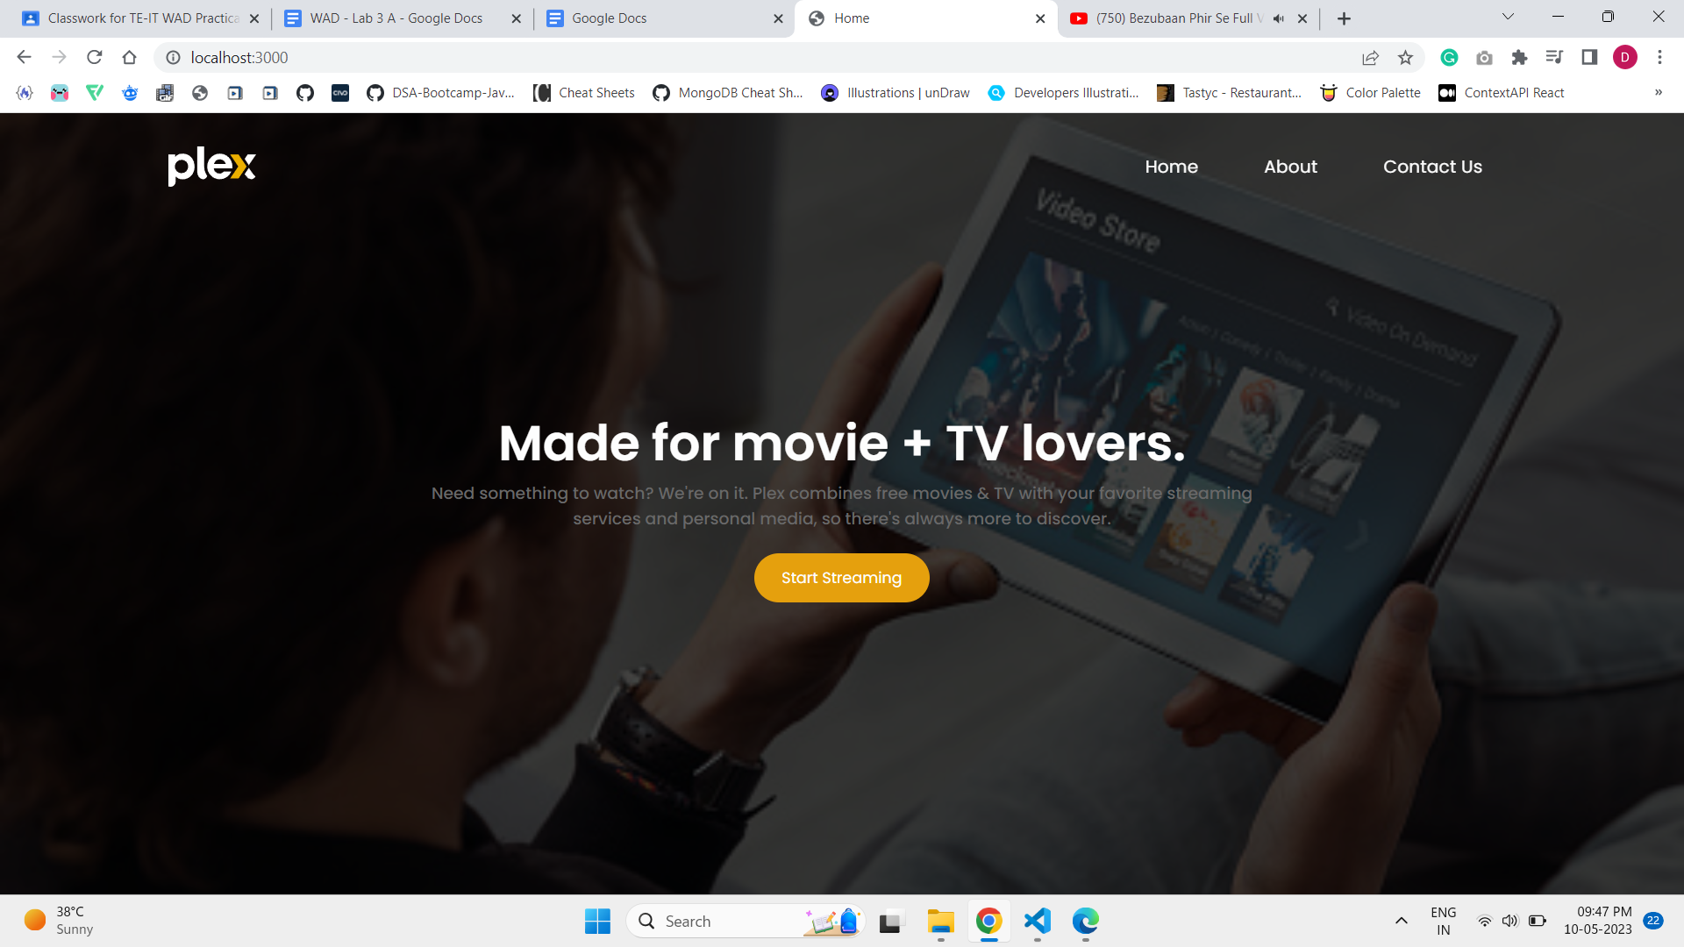

**About**

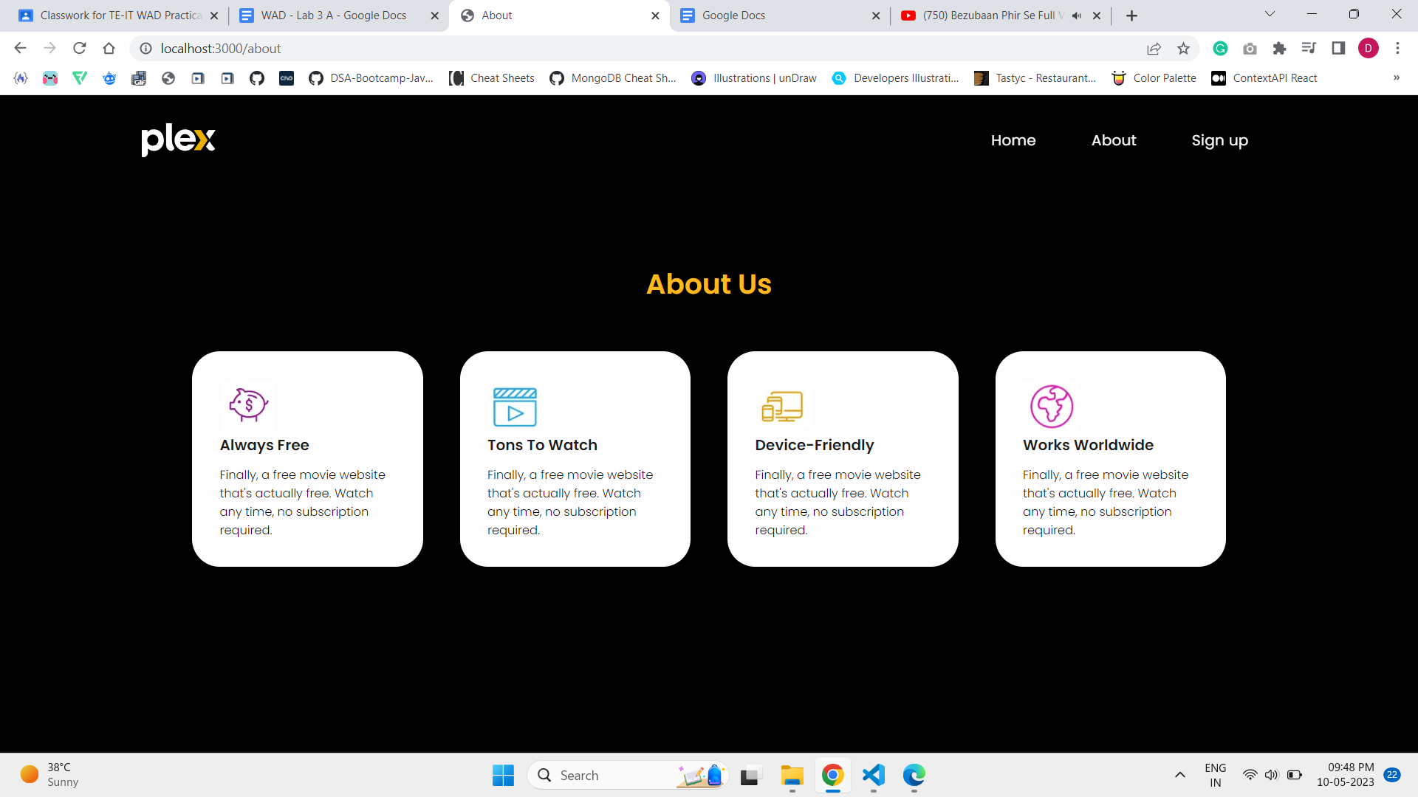

**Contact**

